ABSTRACT
Groundwater Modelling is an efficient tool for groundwater management and remediation. Models are a simplification of reality to investigate certain phenomena or to predict future behavior. The challenge is to simplify reality in a way that does not adversely influence the accuracy and ability of the model output to meet the intended objectives. Despite their efficiency, models can be complicated and produce wrong results if they are not properly designed and interpreted. Regardless of the type of model being used, similar sequences should be followed in modelling. To help selecting the proper model, modelling objectives should be clear and well identified. If the conceptual model is not properly designed, all modelling processes will be a waste of time and effort. To build a proper conceptual model, hydrogeo logical data should be sufficient and reliable. Calibration and verification are the last steps in modelling before writing the final model report. This chapter discusses the stepwise methodology of groundwater modelling with explanation of each step. It contains a brief description of different types of models and different types of solutions. In addition, special difficulties and common mistakes in modelling have been discussed.

1.INTRODUCTION
Groundwater modelling is a way to represent a system in another form to investigate the response of the system under certain conditions, or to predict the behaviour of the system in the future. Groundwater modelling is a powerful tool for water resources management, groundwater protection and remediation. Decision makers use models to predict the behaviour of a groundwater system prior to implementation of a project or to implement a remediation scheme. Clearly, it is a simple and cheap solution compared to project establishment in reality. By definition, models simplify reality, and are, therefore, imperfect. The famous statistician George Box insisted, “ all models are wrong, but some are useful” (Box and Draper 1987). Applicability of any model and its usage depends on the objectives of that model. Though they are imperfect, models are very useful in hydrogeology. It is a challenge to the modeller to represent the real word problem in a simplified form without compromising the accuracy or making invalid assumptions. Modellers try to get the best representation of reality by collecting as much data as possible and feeding the models with new data. Groundwater models can be classified into three categories: physical, analogue or mathematical. Solution of mathematical models can be either analytical or numerical. Analytical methods do not require much data, but their application is limited to simple problems. Numerical solutions can handle more complicated problems than analytical solutions. With the rapid development of computer processors and increasing speed, numerical modelling has become more effective and easy to use. The most commonly used numerical modelling approaches are the “finite difference” method and the “finite element” method. Each method has its advantages and limitations. Depending on the problem of concern and the objectives of modelling, the appropriate modelling approach can be selected. Finite difference method can produce different results to finite element method if the problem of concern is complicated. Modelling approach is not the only factor that affects the model’s results. Other factors like boundary conditions, initial condition, time and space discritisation, and quality of data influence the results. This chapter outlines the stepwise methodology of groundwater modelling, differences between modelling approaches and difficulties accompany groundwater modelling. Common mistakes in groundwater modelling are also discussed.

2.LITERATURE SURVEY

  - Stochastic modelling and risk analysis of groundwater pollution using FORM coupled with automatic differentiation
AUTHORS: Baalousha, H and Köngeter, J.
ABSTRACT: The first order reliability method (FORM) has been widely used in probabilistic modelling of groundwater problems. The FORM approach requires an iterative optimization procedure to find out the system failure point (the most probable point).The advantages of this approach are that it does not require many computations in comparison with other methods when applied to simple problems, and it produces reasonably accurate results. However, it has been found that the computations of FORM can equal or exceed that of other methods in case of large number of variables.In this paper, a new implementation of FORM was proposed with more efficiency and accuracy than the traditional FORM method. In the proposed approach, automatic differentiation is used to obtain the gradient vector of the limit state function, which is required by FORM, instead of using finite difference estimation. This way, the first order derivative was obtained with a very good accuracy, and with less computational effort. Based on the obtained results, it is found that the proposed implementation of FORM is a very good tool for probabilistic risk assessment and uncertainty analysis in groundwater problems.
2.2 Application of Automatic Differentiation in Groundwater Sensitivity Analysis
AUTHORS: Baalousha, H.
ABSTRACT: Derivatives of functions are used very often in groundwater modelling. Computation of sensitivity, optimization problems and inverse modelling require evaluating of derivatives. The most commonly used method for derivative estimation is the finite difference method. This method, however, suffers from poor accuracy and its result is highly dependent on the step size of the finite difference. In addition, the method is slow and requires solving the function many times to obtain the derivative. Automatic differentiation is a powerful technique to compute the derivatives of a function given by a piece of code. The derivative of a two-dimensional finite element groundwater flow and contaminant transport model (MCB2D) was obtained using Automatic Differentiation of Fortran (ADIFOR) and was used for groundwater sensitivity analysis. Two input parameters were considered as uncertain (random): hydraulic conductivity and groundwater recharge. Sensitivity analysis was done to see the effect of the hydraulic conductivity and groundwater recharge on the model output. Sensitivity analysis has shown that the model results are more sensitive to changes in hydraulic conductivity than groundwater recharge. Uncertainty analysis was also done to investigate the effect of uncertainty in model input parameters on the model output. The uncertainty in input parameters was changed by considering different values of coefficient of variation (COV). Results of uncertainty analysis show that the uncertainty in hydraulic conductivity has more impact on the model results than the uncertainty in groundwater recharge. As the uncertainty in model parameters increase, the model underestimates the output. The results achieved in this study have revealed that automatic differentiation is an efficient tool for sensitivity analysis. Automatic differentiation is easy to apply on most groundwater models and does not require knowledge of the model code. The application of automatic differentiation is very promising in groundwater modelling as it reduces the uncertainty of classical differentiation methods.

2.3 Conditional expectation for evaluation of risk groundwater flow and solute transport: one-dimensional analysis.
AUTHORS: Liou, T. and Der Yeh, H.
ABSTRACT: A one-dimensional groundwater transport equation with two uncertain parameters, groundwater velocity and longitudinal dispersity, is investigated in this paper. The analytical uncertainty of the predicted contaminant concentration is derived by the first-order mean-centered uncertainty analysis. The risk of the contaminant transport is defined as the probability that the concentration exceeds a maximum acceptable upper limit. Five probability density functions including the normal, lognormal, gamma, Gumbel, and Weibull distributions are chosen as the models for predicting the concentration distribution. The risk for each distribution is derived analytically based on the conditional probability. The mean risk and confidence interval are then computed by Monte Carlo simulation where the groundwater velocity and longitudinal dispersivity are assumed to be lognormally and normally distributed, respectively. Results from the conditional expectation of an assumed damage function show that the unconditional expectation generally underestimates the damage for low risk events. It is found from the sensitivity analysis that the mean longitudinal dispersivity is the most sensitive parameter and the variance of longitudinal dispersivity is the least sensitive one among those distribution models except the gamma and Weibull distributions.

2.4 The practical use of simplicity in developing groundwater models.
AUTHORS: Hill, Mary
ABSTRACT: The advantages of starting with simple models and building complexity slowly can be significant in the development of ground water models. In many circumstances, simpler models are characterized by fewer defined parameters and shorter execution times. In this work, the number of parameters is used as the primary measure of simplicity and complexity; the advantages of shorter execution times also are considered. The ideas are presented in the context of constructing ground water models but are applicable to many fields. Simplicity first is put in perspective as part of the entire modeling process using 14 guidelines for effective model calibration. It is noted that neither very simple nor very complex models generally produce the most accurate predictions and that determining the appropriate level of complexity is an ill-defined process. It is suggested that a thorough evaluation of observation errors is essential to model development. Finally, specific ways are discussed to design useful ground water models that have fewer parameters and shorter execution times.

2.5 Verification, Validation, and Confirmation of Numerical Models in the Earth Sciences.
AUTHORS: Oreskes, N., Shrader-Frechette, K. and Belitz, K
ABSTRACT: Verification and validation of numerical models of natural systems is impossible. This is because natural systems are never closed and because model results are always nonunique. Models can be confirmed by the demonstration of agreement between observation and prediction, but confirmation is inherently partial. Complete confirmation is logically precluded by the fallacy of affirming the consequent and by incomplete access to natural phenomena. Models can only be evaluated in relative terms, and their predictive value is always open to question. The primary value of models is heuristic.
3.SYSTEM ANALYSIS
3.1 EXISTING SYSTEM:
Application of existing groundwater models include water balance (in terms of water quantity), gaining knowledge about the quantitative aspects of the unsaturated zone, simulating of water flow and chemical migration in the saturated zone including river-groundwater relations, assessing the impact of changes of the groundwater regime on the environment, setting up/optimising monitoring networks, and setting up groundwater protection zones.

  - PROPOSED SYSTEM:
The modelling studies in India have so far been confined to academic and research organisations. The practising professionals mostly still prefer to employ lumped models for planning of groundwater development and recharge. Such models completely ignore the distributed character of the groundwater regime. Thus, they are based upon rather conservative concepts like safe yields and are incapable of accounting for the stream-aquifer interaction and the dependence of lateral recharge on the water table pattern. Consequently, permissible mining (i.e. withdrawals in excess of vertical recharge) and perennial yield can not be arrived at. The objectives of modelling studies in India have been mainly (i) groundwater recharge, (ii) dynamic behaviour of the water table, (iii) stream-aquifer interaction, and (iv) sea-water intrusion etc.
3.3 SYSTEM REQUIREMENTS:
HARDWARE REQUIREMENTS:

- System : Pentium IV 2.4 GHz.
- Hard Disk : 40 GB.
- Floppy Drive : 1.44 Mb.
- Monitor : 15 VGA Colour.
- Mouse : Logitech.
- Ram : 512 Mb.

SOFTWARE REQUIREMENTS:

- Operating System: Windows
- Coding Language: Python 3.7

3.4 SYSTEM STUDY

FEASIBILITY STUDY

The feasibility of the project is analyzed in this phase and business proposal is put forth with a very general plan for the project and some cost estimates. During system analysis the feasibility study of the proposed system is to be carried out. This is to ensure that the proposed system is not a burden to the company. For feasibility analysis, some understanding of the major requirements for the system is essential.

Three key considerations involved in the feasibility analysis are

- ECONOMICAL FEASIBILITY
- TECHNICAL FEASIBILITY
- SOCIAL FEASIBILITY

ECONOMICAL FEASIBILITY

This study is carried out to check the economic impact that the system will have on the organization. The amount of fund that the company can pour into the research and development of the system is limited. The expenditures must be justified. Thus the developed system as well within the budget and this was achieved because most of the technologies used are freely available. Only the customized products had to be purchased.

TECHNICAL FEASIBILITY

This study is carried out to check the technical feasibility, that is, the technical requirements of the system. Any system developed must not have a high demand on the available technical resources. This will lead to high demands on the available technical resources. This will lead to high demands being placed on the client. The developed system must have a modest requirement, as only minimal or null changes are required for implementing this system.

SOCIAL FEASIBILITY

The aspect of study is to check the level of acceptance of the system by the user. This includes the process of training the user to use the system efficiently. The user must not feel threatened by the system, instead must accept it as a necessity. The level of acceptance by the users solely depends on the methods that are employed to educate the user about the system and to make him familiar with it. His level of confidence must be raised so that he is also able to make some constructive criticism, which is welcomed, as he is the final user of the system.

4.SYSTEM DESIGN
4.1 SYSTEM ARCHITECTURE:

4.2 DATA FLOW DIAGRAM:

- The DFD is also called as bubble chart. It is a simple graphical formalism that can be used to represent a system in terms of input data to the system, various processing carried out on this data, and the output data is generated by this system.
- The data flow diagram (DFD) is one of the most important modeling tools. It is used to model the system components. These components are the system process, the data used by the process, an external entity that interacts with the system and the information flows in the system.
- DFD shows how the information moves through the system and how it is modified by a series of transformations. It is a graphical technique that depicts information flow and the transformations that are applied as data moves from input to output.
- DFD is also known as bubble chart. A DFD may be used to represent a system at any level of abstraction. DFD may be partitioned into levels that represent increasing information flow and functional detail.

User
Check

YES NO
Unauthorized user

Upload Ground Water Dataset

Generate Train & Test Model

Run ANN with crow Search GA
Gesture

Run ANN with Gray Wolf GA

MSE Comparison Graph
End process

4.3 UML DIAGRAMS
UML stands for Unified Modeling Language. UML is a standardized general-purpose modeling language in the field of object-oriented software engineering. The standard is managed, and was created by, the Object Management Group.
The goal is for UML to become a common language for creating models of object oriented computer software. In its current form UML is comprised of two major components: a Meta-model and a notation. In the future, some form of method or process may also be added to; or associated with, UML.
The Unified Modeling Language is a standard language for specifying, Visualization, Constructing and documenting the artifacts of software system, as well as for business modeling and other non-software systems.
The UML represents a collection of best engineering practices that have proven successful in the modeling of large and complex systems.
The UML is a very important part of developing objects oriented software and the software development process. The UML uses mostly graphical notations to express the design of software projects.

GOALS:
The Primary goals in the design of the UML are as follows:
- Provide users a ready-to-use, expressive visual modeling Language so that they can develop and exchange meaningful models.
- Provide extendibility and specialization mechanisms to extend the core concepts.
- Be independent of particular programming languages and development process.
- Provide a formal basis for understanding the modeling language.
- Encourage the growth of OO tools market.
- Support higher level development concepts such as collaborations, frameworks, patterns and components.
- Integrate best practices.

USE CASE DIAGRAM:
A use case diagram in the Unified Modeling Language (UML) is a type of behavioral diagram defined by and created from a Use-case analysis. Its purpose is to present a graphical overview of the functionality provided by a system in terms of actors, their goals (represented as use cases), and any dependencies between those use cases. The main purpose of a use case diagram is to show what system functions are performed for which actor. Roles of the actors in the system can be depicted.

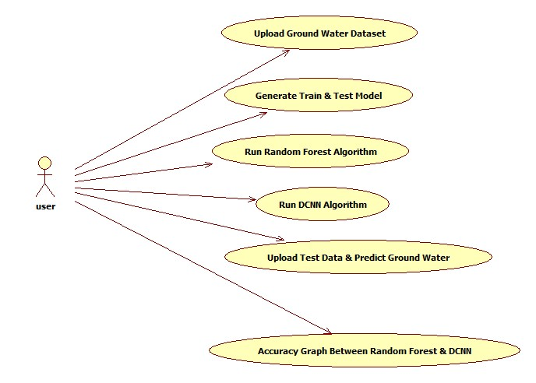

CLASS DIAGRAM:
In software engineering, a class diagram in the Unified Modeling Language (UML) is a type of static structure diagram that describes the structure of a system by showing the system's classes, their attributes, operations (or methods), and the relationships among the classes. It explains which class contains information.

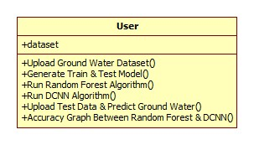

SEQUENCE DIAGRAM:
A sequence diagram in Unified Modeling Language (UML) is a kind of interaction diagram that shows how processes operate with one another and in what order. It is a construct of a Message Sequence Chart. Sequence diagrams are sometimes called event diagrams, event scenarios, and timing diagrams.

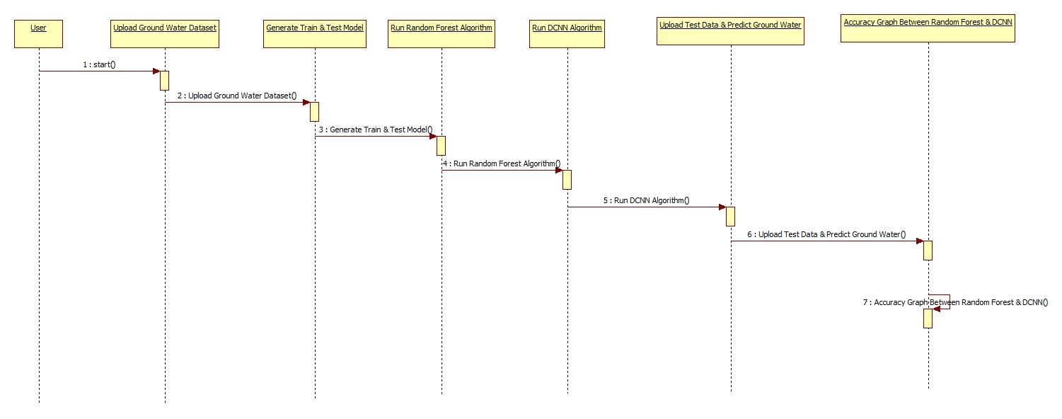

ACTIVITY DIAGRAM:
Activity diagrams are graphical representations of workflows of stepwise activities and actions with support for choice, iteration and concurrency. In the Unified Modeling Language, activity diagrams can be used to describe the business and operational step-by-step workflows of components in a system. An activity diagram shows the overall flow of control.
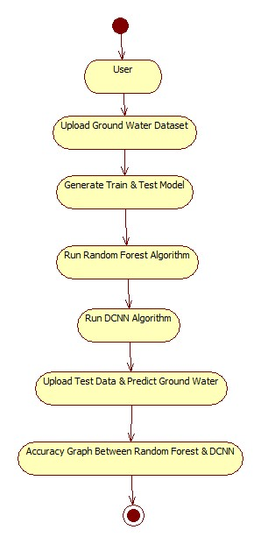

4.3 IMPLEMENTATION:
MODULES:

Upload Ground Water Dataset
Generate Train & Test Model
Run Random Forest Algorithm
Run DCNN Algorithm
Upload Test Data & Predict Ground Water
Accuracy Graph Between Random Forest & DCNN

ALGORITHMS
To demonstrate how to build a convolutional neural network based water level classifier, we shall build a 6 layer neural network that will identify and separate one water level from other. This network that we shall build is a very small network that we can run on a CPU as well. Traditional neural networks that are very good at doing image classification have many more parameters and take a lot of time if trained on normal CPU. However, our objective is to show how to build a real-world convolutional neural network using TENSORFLOW.
Neural Networks are essentially mathematical models to solve an optimization problem. They are made of neurons, the basic computation unit of neural networks. A neuron takes an input (say x), do some computation on it (say: multiply it with a variable w and adds another variable b) to produce a value (say; z= wx+b). This value is passed to a non-linear function called activation function (f) to produce the final output(activation) of a neuron. There are many kinds of activation functions. One of the popular activation function is Sigmoid. The neuron which uses sigmoid function as an activation function will be called sigmoid neuron. Depending on the activation functions, neurons are named and there are many kinds of them like RELU, TanH.
If you stack neurons in a single line, it’s called a layer; which is the next building block of neural networks. See below image with layers
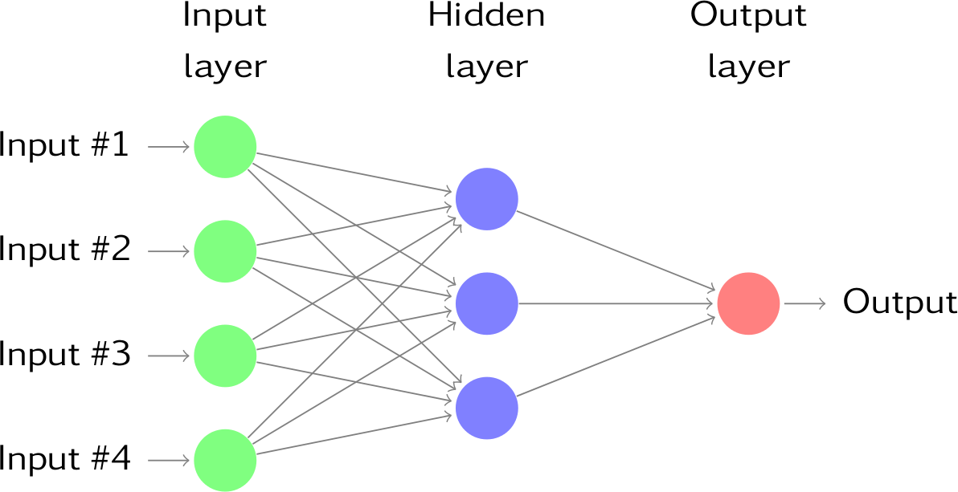
To predict water level class multiple layers operate on each other to get best match layer and this process continues till no more improvement left.

5.SOFTWARE ENVIRONMENT

What is Python :-
Below are some facts about Python.
Python is currently the most widely used multi-purpose, high-level programming language.
Python allows programming in Object-Oriented and Procedural paradigms. Python programs generally are smaller than other programming languages like Java.
Programmers have to type relatively less and indentation requirement of the language, makes them readable all the time.
Python language is being used by almost all tech-giant companies like – Google, Amazon, Facebook, Instagram, Dropbox, Uber… etc.
The biggest strength of Python is huge collection of standard library which can be used for the following –
  - Machine Learning
  - GUI Applications (like Kivy, Tkinter, PyQt etc. )
  - Web frameworks like Django (used by YouTube, Instagram, Dropbox)
  - Image processing (like Opencv, Pillow)
  - Web scraping (like Scrapy, BeautifulSoup, Selenium)
  - Test frameworks
  - Multimedia

Advantages of Python :-
Let’s see how Python dominates over other languages.

1. Extensive Libraries
Python downloads with an extensive library and it contain code for various purposes like regular expressions, documentation-generation, unit-testing, web browsers, threading, databases, CGI, email, image manipulation, and more. So, we don’t have to write the complete code for that manually.

2. Extensible
As we have seen earlier, Python can be extended to other languages. You can write some of your code in languages like C++ or C. This comes in handy, especially in projects.

3. Embeddable
Complimentary to extensibility, Python is embeddable as well. You can put your Python code in your source code of a different language, like C++. This lets us add scripting capabilities to our code in the other language.

4. Improved Productivity
The language’s simplicity and extensive libraries render programmers more productive than languages like Java and C++ do. Also, the fact that you need to write less and get more things done.

5. IOT Opportunities
Since Python forms the basis of new platforms like Raspberry Pi, it finds the future bright for the Internet Of Things. This is a way to connect the language with the real world.

6. Simple and Easy
When working with Java, you may have to create a class to print ‘Hello World’. But in Python, just a print statement will do. It is also quite easy to learn, understand, and code. This is why when people pick up Python, they have a hard time adjusting to other more verbose languages like Java.

7. Readable
Because it is not such a verbose language, reading Python is much like reading English. This is the reason why it is so easy to learn, understand, and code. It also does not need curly braces to define blocks, and indentation is mandatory. This further aids the readability of the code.

8. Object-Oriented
This language supports both the procedural and object-oriented programming paradigms. While functions help us with code reusability, classes and objects let us model the real world. A class allows the encapsulation of data and functions into one.

9. Free and Open-Source
Like we said earlier, Python is freely available. But not only can you download Python for free, but you can also download its source code, make changes to it, and even distribute it. It downloads with an extensive collection of libraries to help you with your tasks.

10. Portable
When you code your project in a language like C++, you may need to make some changes to it if you want to run it on another platform. But it isn’t the same with Python. Here, you need to code only once, and you can run it anywhere. This is called Write Once Run Anywhere (WORA). However, you need to be careful enough not to include any system-dependent features.

11. Interpreted
Lastly, we will say that it is an interpreted language. Since statements are executed one by one, debugging is easier than in compiled languages.
Any doubts till now in the advantages of Python? Mention in the comment section.

Advantages of Python Over Other Languages

1. Less Coding
Almost all of the tasks done in Python requires less coding when the same task is done in other languages. Python also has an awesome standard library support, so you don’t have to search for any third-party libraries to get your job done. This is the reason that many people suggest learning Python to beginners.

2. Affordable
Python is free therefore individuals, small companies or big organizations can leverage the free available resources to build applications. Python is popular and widely used so it gives you better community support.
The 2019 Github annual survey showed us that Python has overtaken Java in the most popular programming language category.

3. Python is for Everyone
Python code can run on any machine whether it is Linux, Mac or Windows. Programmers need to learn different languages for different jobs but with Python, you can professionally build web apps, perform data analysis and machine learning, automate things, do web scraping and also build games and powerful visualizations. It is an all-rounder programming language.

Disadvantages of Python
So far, we’ve seen why Python is a great choice for your project. But if you choose it, you should be aware of its consequences as well. Let’s now see the downsides of choosing Python over another language.

1. Speed Limitations
We have seen that Python code is executed line by line. But since Python is interpreted, it often results in slow execution. This, however, isn’t a problem unless speed is a focal point for the project. In other words, unless high speed is a requirement, the benefits offered by Python are enough to distract us from its speed limitations.

2. Weak in Mobile Computing and Browsers
While it serves as an excellent server-side language, Python is much rarely seen on the client-side. Besides that, it is rarely ever used to implement smartphone-based applications. One such application is called Carbonnelle.
The reason it is not so famous despite the existence of Brython is that it isn’t that secure.

3. Design Restrictions
As you know, Python is dynamically-typed. This means that you don’t need to declare the type of variable while writing the code. It uses duck-typing. But wait, what’s that? Well, it just means that if it looks like a duck, it must be a duck. While this is easy on the programmers during coding, it can raise run-time errors.

4. Underdeveloped Database Access Layers
Compared to more widely used technologies like JDBC (Java DataBase Connectivity) and ODBC (Open DataBase Connectivity), Python’s database access layers are a bit underdeveloped. Consequently, it is less often applied in huge enterprises.

5. Simple
No, we’re not kidding. Python’s simplicity can indeed be a problem. Take my example. I don’t do Java, I’m more of a Python person. To me, its syntax is so simple that the verbosity of Java code seems unnecessary.
This was all about the Advantages and Disadvantages of Python Programming Language.
History of Python : -

What do the alphabet and the programming language Python have in common? Right, both start with ABC. If we are talking about ABC in the Python context, it's clear that the programming language ABC is meant. ABC is a general-purpose programming language and programming environment, which had been developed in the Netherlands, Amsterdam, at the CWI (Centrum Wiskunde &Informatica). The greatest achievement of ABC was to influence the design of Python.Python was conceptualized in the late 1980s. Guido van Rossum worked that time in a project at the CWI, called Amoeba, a distributed operating system. In an interview with Bill Venners¹, Guido van Rossum said: "In the early 1980s, I worked as an implementer on a team building a language called ABC at Centrum voor Wiskunde en Informatica (CWI). I don't know how well people know ABC's influence on Python. I try to mention ABC's influence because I'm indebted to everything I learned during that project and to the people who worked on it."Later on in the same Interview, Guido van Rossum continued: "I remembered all my experience and some of my frustration with ABC. I decided to try to design a simple scripting language that possessed some of ABC's better properties, but without its problems. So I started typing. I created a simple virtual machine, a simple parser, and a simple runtime. I made my own version of the various ABC parts that I liked. I created a basic syntax, used indentation for statement grouping instead of curly braces or begin-end blocks, and developed a small number of powerful data types: a hash table (or dictionary, as we call it), a list, strings, and numbers."
What is Machine Learning : -
Before we take a look at the details of various machine learning methods, let's start by looking at what machine learning is, and what it isn't. Machine learning is often categorized as a subfield of artificial intelligence, but I find that categorization can often be misleading at first brush. The study of machine learning certainly arose from research in this context, but in the data science application of machine learning methods, it's more helpful to think of machine learning as a means of building models of data.
Fundamentally, machine learning involves building mathematical models to help understand data. "Learning" enters the fray when we give these models tunable parameters that can be adapted to observed data; in this way the program can be considered to be "learning" from the data. Once these models have been fit to previously seen data, they can be used to predict and understand aspects of newly observed data. I'll leave to the reader the more philosophical digression regarding the extent to which this type of mathematical, model-based "learning" is similar to the "learning" exhibited by the human brain.Understanding the problem setting in machine learning is essential to using these tools effectively, and so we will start with some broad categorizations of the types of approaches we'll discuss here.
Categories Of Machine Leaning :-
At the most fundamental level, machine learning can be categorized into two main types: supervised learning and unsupervised learning.
Supervised learning involves somehow modeling the relationship between measured features of data and some label associated with the data; once this model is determined, it can be used to apply labels to new, unknown data. This is further subdivided into classification tasks and regression tasks: in classification, the labels are discrete categories, while in regression, the labels are continuous quantities. We will see examples of both types of supervised learning in the following section.
Unsupervised learning involves modeling the features of a dataset without reference to any label, and is often described as "letting the dataset speak for itself." These models include tasks such as clustering and dimensionality reduction. Clustering algorithms identify distinct groups of data, while dimensionality reduction algorithms search for more succinct representations of the data. We will see examples of both types of unsupervised learning in the following section.

Need for Machine Learning
Human beings, at this moment, are the most intelligent and advanced species on earth because they can think, evaluate and solve complex problems. On the other side, AI is still in its initial stage and haven’t surpassed human intelligence in many aspects. Then the question is that what is the need to make machine learn? The most suitable reason for doing this is, “to make decisions, based on data, with efficiency and scale”.
Lately, organizations are investing heavily in newer technologies like Artificial Intelligence, Machine Learning and Deep Learning to get the key information from data to perform several real-world tasks and solve problems. We can call it data-driven decisions taken by machines, particularly to automate the process. These data-driven decisions can be used, instead of using programing logic, in the problems that cannot be programmed inherently. The fact is that we can’t do without human intelligence, but other aspect is that we all need to solve real-world problems with efficiency at a huge scale. That is why the need for machine learning arises.

Challenges in Machines Learning :-

While Machine Learning is rapidly evolving, making significant strides with cybersecurity and autonomous cars, this segment of AI as whole still has a long way to go. The reason behind is that ML has not been able to overcome number of challenges. The challenges that ML is facing currently are −
Quality of data − Having good-quality data for ML algorithms is one of the biggest challenges. Use of low-quality data leads to the problems related to data preprocessing and feature extraction.
Time-Consuming task − Another challenge faced by ML models is the consumption of time especially for data acquisition, feature extraction and retrieval.
Lack of specialist persons − As ML technology is still in its infancy stage, availability of expert resources is a tough job.
No clear objective for formulating business problems − Having no clear objective and well-defined goal for business problems is another key challenge for ML because this technology is not that mature yet.
Issue of overfitting & underfitting − If the model is overfitting or underfitting, it cannot be represented well for the problem.
Curse of dimensionality − Another challenge ML model faces is too many features of data points. This can be a real hindrance.
Difficulty in deployment − Complexity of the ML model makes it quite difficult to be deployed in real life.

Applications of Machines Learning :-

Machine Learning is the most rapidly growing technology and according to researchers we are in the golden year of AI and ML. It is used to solve many real-world complex problems which cannot be solved with traditional approach. Following are some real-world applications of ML −
- Emotion analysis
- Sentiment analysis
- Error detection and prevention
- Weather forecasting and prediction
- Stock market analysis and forecasting
- Speech synthesis
- Speech recognition
- Customer segmentation
- Object recognition
- Fraud detection
- Fraud prevention
- Recommendation of products to customer in online shopping

How to Start Learning Machine Learning?
Arthur Samuel coined the term “Machine Learning” in 1959 and defined it as a “Field of study that gives computers the capability to learn without being explicitly programmed”.
And that was the beginning of Machine Learning! In modern times, Machine Learning is one of the most popular (if not the most!) career choices. According to Indeed, Machine Learning Engineer Is The Best Job of 2019 with a 344% growth and an average base salary of $146,085 per year.
But there is still a lot of doubt about what exactly is Machine Learning and how to start learning it? So this article deals with the Basics of Machine Learning and also the path you can follow to eventually become a full-fledged Machine Learning Engineer. Now let’s get started!!!

How to start learning ML?
This is a rough roadmap you can follow on your way to becoming an insanely talented Machine Learning Engineer. Of course, you can always modify the steps according to your needs to reach your desired end-goal!

Step 1 – Understand the Prerequisites
In case you are a genius, you could start ML directly but normally, there are some prerequisites that you need to know which include Linear Algebra, Multivariate Calculus, Statistics, and Python. And if you don’t know these, never fear! You don’t need a Ph.D. degree in these topics to get started but you do need a basic understanding.

(a) Learn Linear Algebra and Multivariate Calculus
Both Linear Algebra and Multivariate Calculus are important in Machine Learning. However, the extent to which you need them depends on your role as a data scientist. If you are more focused on application heavy machine learning, then you will not be that heavily focused on maths as there are many common libraries available. But if you want to focus on R&D in Machine Learning, then mastery of Linear Algebra and Multivariate Calculus is very important as you will have to implement many ML algorithms from scratch.

(b) Learn Statistics
Data plays a huge role in Machine Learning. In fact, around 80% of your time as an ML expert will be spent collecting and cleaning data. And statistics is a field that handles the collection, analysis, and presentation of data. So it is no surprise that you need to learn it!!!
Some of the key concepts in statistics that are important are Statistical Significance, Probability Distributions, Hypothesis Testing, Regression, etc. Also, Bayesian Thinking is also a very important part of ML which deals with various concepts like Conditional Probability, Priors, and Posteriors, Maximum Likelihood, etc.

(c) Learn Python
Some people prefer to skip Linear Algebra, Multivariate Calculus and Statistics and learn them as they go along with trial and error. But the one thing that you absolutely cannot skip is Python! While there are other languages you can use for Machine Learning like R, Scala, etc. Python is currently the most popular language for ML. In fact, there are many Python libraries that are specifically useful for Artificial Intelligence and Machine Learning such as Keras, TensorFlow, Scikit-learn, etc.
So if you want to learn ML, it’s best if you learn Python! You can do that using various online resources and courses such as Fork Python available Free on GeeksforGeeks.

Step 2 – Learn Various ML Concepts
Now that you are done with the prerequisites, you can move on to actually learning ML (Which is the fun part!!!) It’s best to start with the basics and then move on to the more complicated stuff. Some of the basic concepts in ML are:

(a) Terminologies of Machine Learning
- Model – A model is a specific representation learned from data by applying some machine learning algorithm. A model is also called a hypothesis.
- Feature – A feature is an individual measurable property of the data. A set of numeric features can be conveniently described by a feature vector. Feature vectors are fed as input to the model. For example, in order to predict a fruit, there may be features like color, smell, taste, etc.
- Target (Label) – A target variable or label is the value to be predicted by our model. For the fruit example discussed in the feature section, the label with each set of input would be the name of the fruit like apple, orange, banana, etc.
- Training – The idea is to give a set of inputs(features) and it’s expected outputs(labels), so after training, we will have a model (hypothesis) that will then map new data to one of the categories trained on.
- Prediction – Once our model is ready, it can be fed a set of inputs to which it will provide a predicted output(label).

(b) Types of Machine Learning
- Supervised Learning – This involves learning from a training dataset with labeled data using classification and regression models. This learning process continues until the required level of performance is achieved.
- Unsupervised Learning – This involves using unlabelled data and then finding the underlying structure in the data in order to learn more and more about the data itself using factor and cluster analysis models.
- Semi-supervised Learning – This involves using unlabelled data like Unsupervised Learning with a small amount of labeled data. Using labeled data vastly increases the learning accuracy and is also more cost-effective than Supervised Learning.
- Reinforcement Learning – This involves learning optimal actions through trial and error. So the next action is decided by learning behaviors that are based on the current state and that will maximize the reward in the future.

Advantages of Machine learning :-

1. Easily identifies trends and patterns -
Machine Learning can review large volumes of data and discover specific trends and patterns that would not be apparent to humans. For instance, for an e-commerce website like Amazon, it serves to understand the browsing behaviors and purchase histories of its users to help cater to the right products, deals, and reminders relevant to them. It uses the results to reveal relevant advertisements to them.

2. No human intervention needed (automation)
With ML, you don’t need to babysit your project every step of the way. Since it means giving machines the ability to learn, it lets them make predictions and also improve the algorithms on their own. A common example of this is anti-virus softwares; they learn to filter new threats as they are recognized. ML is also good at recognizing spam.

3. Continuous Improvement
As ML algorithms gain experience, they keep improving in accuracy and efficiency. This lets them make better decisions. Say you need to make a weather forecast model. As the amount of data you have keeps growing, your algorithms learn to make more accurate predictions faster.

4. Handling multi-dimensional and multi-variety data
Machine Learning algorithms are good at handling data that are multi-dimensional and multi-variety, and they can do this in dynamic or uncertain environments.

5. Wide Applications
You could be an e-tailer or a healthcare provider and make ML work for you. Where it does apply, it holds the capability to help deliver a much more personal experience to customers while also targeting the right customers.

Disadvantages of Machine Learning :-

1. Data Acquisition
Machine Learning requires massive data sets to train on, and these should be inclusive/unbiased, and of good quality. There can also be times where they must wait for new data to be generated.

2. Time and Resources
ML needs enough time to let the algorithms learn and develop enough to fulfill their purpose with a considerable amount of accuracy and relevancy. It also needs massive resources to function. This can mean additional requirements of computer power for you.

3. Interpretation of Results
Another major challenge is the ability to accurately interpret results generated by the algorithms. You must also carefully choose the algorithms for your purpose.

4. High error-susceptibility
Machine Learning is autonomous but highly susceptible to errors. Suppose you train an algorithm with data sets small enough to not be inclusive. You end up with biased predictions coming from a biased training set. This leads to irrelevant advertisements being displayed to customers. In the case of ML, such blunders can set off a chain of errors that can go undetected for long periods of time. And when they do get noticed, it takes quite some time to recognize the source of the issue, and even longer to correct it.

Python Development Steps : -
Guido Van Rossum published the first version of Python code (version 0.9.0) at alt.sources in February 1991. This release included already exception handling, functions, and the core data types of list, dict, str and others. It was also object oriented and had a module system.
Python version 1.0 was released in January 1994. The major new features included in this release were the functional programming tools lambda, map, filter and reduce, which Guido Van Rossum never liked.Six and a half years later in October 2000, Python 2.0 was introduced. This release included list comprehensions, a full garbage collector and it was supporting unicode.Python flourished for another 8 years in the versions 2.x before the next major release as Python 3.0 (also known as "Python 3000" and "Py3K") was released. Python 3 is not backwards compatible with Python 2.x. The emphasis in Python 3 had been on the removal of duplicate programming constructs and modules, thus fulfilling or coming close to fulfilling the 13th law of the Zen of Python: "There should be one -- and preferably only one -- obvious way to do it."Some changes in Python 7.3:
- Print is now a function
- Views and iterators instead of lists
- The rules for ordering comparisons have been simplified. E.g. a heterogeneous list cannot be sorted, because all the elements of a list must be comparable to each other.
- There is only one integer type left, i.e. int. long is int as well.
- The division of two integers returns a float instead of an integer. "//" can be used to have the "old" behaviour.
- Text Vs. Data Instead Of Unicode Vs. 8-bit
Purpose :-
We demonstrated that our approach enables successful segmentation of intra-retinal layers—even with low-quality images containing speckle noise, low contrast, and different intensity ranges throughout—with the assistance of the ANIS feature.
Python
Python is an interpreted high-level programming language for general-purpose programming. Created by Guido van Rossum and first released in 1991, Python has a design philosophy that emphasizes code readability, notably using significant whitespace.
Python features a dynamic type system and automatic memory management. It supports multiple programming paradigms, including object-oriented, imperative, functional and procedural, and has a large and comprehensive standard library.
- Python is Interpreted − Python is processed at runtime by the interpreter. You do not need to compile your program before executing it. This is similar to PERL and PHP.
- Python is Interactive − you can actually sit at a Python prompt and interact with the interpreter directly to write your programs.
Python also acknowledges that speed of development is important. Readable and terse code is part of this, and so is access to powerful constructs that avoid tedious repetition of code. Maintainability also ties into this may be an all but useless metric, but it does say something about how much code you have to scan, read and/or understand to troubleshoot problems or tweak behaviors. This speed of development, the ease with which a programmer of other languages can pick up basic Python skills and the huge standard library is key to another area where Python excels. All its tools have been quick to implement, saved a lot of time, and several of them have later been patched and updated by people with no Python background - without breaking.
Modules Used in Project :-
Tensorflow
TensorFlow is a free and open-source software library for dataflow and differentiable programming across a range of tasks. It is a symbolic math library, and is also used for machine learning applications such as neural networks. It is used for both research and production at Google.‍
TensorFlow was developed by the Google Brain team for internal Google use. It was released under the Apache 2.0 open-source license on November 9, 2015.
Numpy
Numpy is a general-purpose array-processing package. It provides a high-performance multidimensional array object, and tools for working with these arrays.
It is the fundamental package for scientific computing with Python. It contains various features including these important ones:
- A powerful N-dimensional array object
- Sophisticated (broadcasting) functions
- Tools for integrating C/C++ and Fortran code
- Useful linear algebra, Fourier transform, and random number capabilities
Besides its obvious scientific uses, Numpy can also be used as an efficient multi-dimensional container of generic data. Arbitrary data-types can be defined using Numpy which allows Numpy to seamlessly and speedily integrate with a wide variety of databases.
Pandas
Pandas is an open-source Python Library providing high-performance data manipulation and analysis tool using its powerful data structures. Python was majorly used for data munging and preparation. It had very little contribution towards data analysis. Pandas solved this problem. Using Pandas, we can accomplish five typical steps in the processing and analysis of data, regardless of the origin of data load, prepare, manipulate, model, and analyze. Python with Pandas is used in a wide range of fields including academic and commercial domains including finance, economics, Statistics, analytics, etc.
Matplotlib
Matplotlib is a Python 2D plotting library which produces publication quality figures in a variety of hardcopy formats and interactive environments across platforms. Matplotlib can be used in Python scripts, the Python and IPython shells, the Jupyter Notebook, web application servers, and four graphical user interface toolkits. Matplotlib tries to make easy things easy and hard things possible. You can generate plots, histograms, power spectra, bar charts, error charts, scatter plots, etc., with just a few lines of code. For examples, see the sample plots and thumbnail gallery.
For simple plotting the pyplot module provides a MATLAB-like interface, particularly when combined with IPython. For the power user, you have full control of line styles, font properties, axes properties, etc, via an object oriented interface or via a set of functions familiar to MATLAB users.
Scikit – learn
Scikit-learn provides a range of supervised and unsupervised learning algorithms via a consistent interface in Python. It is licensed under a permissive simplified BSD license and is distributed under many Linux distributions, encouraging academic and commercial use. Python
Python is an interpreted high-level programming language for general-purpose programming. Created by Guido van Rossum and first released in 1991, Python has a design philosophy that emphasizes code readability, notably using significant whitespace.
Python features a dynamic type system and automatic memory management. It supports multiple programming paradigms, including object-oriented, imperative, functional and procedural, and has a large and comprehensive standard library.
- Python is Interpreted − Python is processed at runtime by the interpreter. You do not need to compile your program before executing it. This is similar to PERL and PHP.
- Python is Interactive − you can actually sit at a Python prompt and interact with the interpreter directly to write your programs.
Python also acknowledges that speed of development is important. Readable and terse code is part of this, and so is access to powerful constructs that avoid tedious repetition of code. Maintainability also ties into this may be an all but useless metric, but it does say something about how much code you have to scan, read and/or understand to troubleshoot problems or tweak behaviors. This speed of development, the ease with which a programmer of other languages can pick up basic Python skills and the huge standard library is key to another area where Python excels. All its tools have been quick to implement, saved a lot of time, and several of them have later been patched and updated by people with no Python background - without breaking.
Install Python Step-by-Step in Windows and Mac :
Python a versatile programming language doesn’t come pre-installed on your computer devices. Python was first released in the year 1991 and until today it is a very popular high-level programming language. Its style philosophy emphasizes code readability with its notable use of great whitespace.
The object-oriented approach and language construct provided by Python enables programmers to write both clear and logical code for projects. This software does not come pre-packaged with Windows.

How to Install Python on Windows and Mac :

There have been several updates in the Python version over the years. The question is how to install Python? It might be confusing for the beginner who is willing to start learning Python but this tutorial will solve your query. The latest or the newest version of Python is version 3.7.4 or in other words, it is Python 3.
Note: The python version 3.7.4 cannot be used on Windows XP or earlier devices.

Before you start with the installation process of Python. First, you need to know about your System Requirements. Based on your system type i.e. operating system and based processor, you must download the python version. My system type is a Windows 64-bit operating system. So the steps below are to install python version 3.7.4 on Windows 7 device or to install Python 3. Download the Python Cheatsheet here.The steps on how to install Python on Windows 10, 8 and 7 are divided into 4 parts to help understand better.

Download the Correct version into the system

Step 1: Go to the official site to download and install python using Google Chrome or any other web browser. OR Click on the following link: https://www.python.org

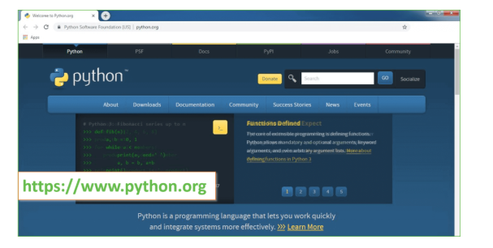
Now, check for the latest and the correct version for your operating system.
Step 2: Click on the Download Tab.
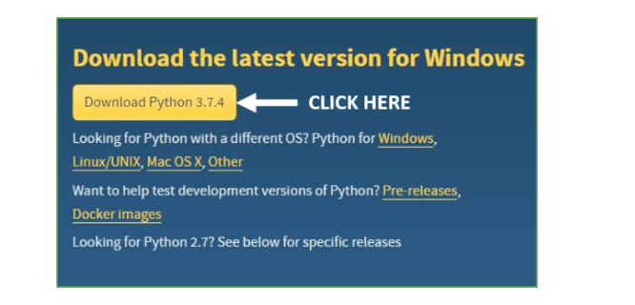
Step 3: You can either select the Download Python for windows 3.7.4 button in Yellow Color or you can scroll further down and click on download with respective to their version. Here, we are downloading the most recent python version for windows 3.7.4
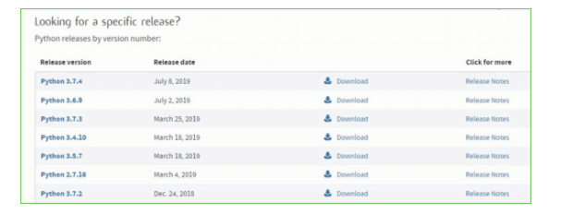
Step 4: Scroll down the page until you find the Files option.

Step 5: Here you see a different version of python along with the operating system.

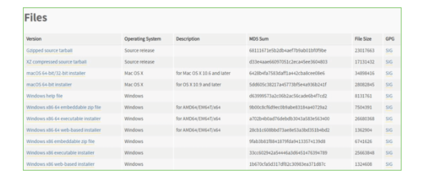

• To download Windows 32-bit python, you can select any one from the three options: Windows x86 embeddable zip file, Windows x86 executable installer or Windows x86 web-based installer.
•To download Windows 64-bit python, you can select any one from the three options: Windows x86-64 embeddable zip file, Windows x86-64 executable installer or Windows x86-64 web-based installer.
Here we will install Windows x86-64 web-based installer. Here your first part regarding which version of python is to be downloaded is completed. Now we move ahead with the second part in installing python i.e. Installation
Note: To know the changes or updates that are made in the version you can click on the Release Note Option.

Installation of Python
Step 1: Go to Download and Open the downloaded python version to carry out the installation process.
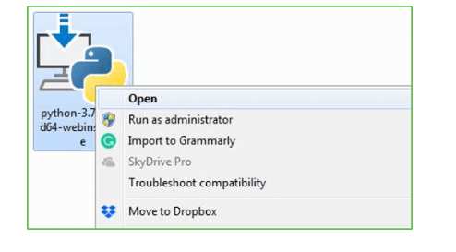
Step 2: Before you click on Install Now, Make sure to put a tick on Add Python 3.7 to PATH.

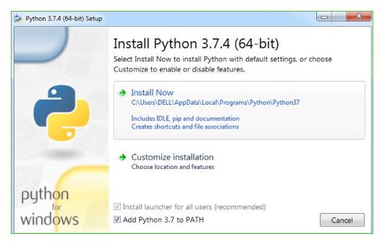

Step 3: Click on Install NOW After the installation is successful. Click on Close.

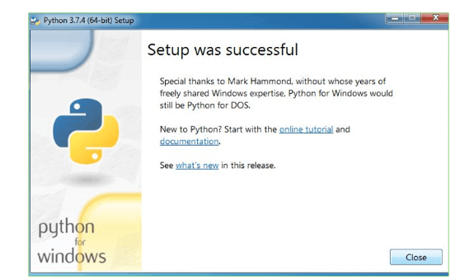

With these above three steps on python installation, you have successfully and correctly installed Python. Now is the time to verify the installation.
Note: The installation process might take a couple of minutes.

Verify the Python Installation
Step 1: Click on Start
Step 2: In the Windows Run Command, type “cmd”.

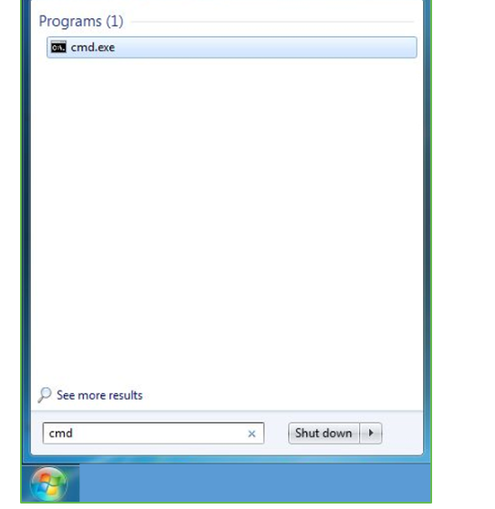
Step 3: Open the Command prompt option.
Step 4: Let us test whether the python is correctly installed. Type python –V and press Enter.

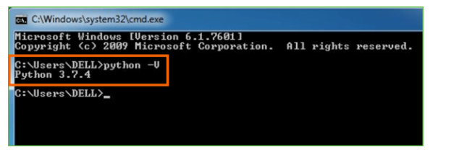
Step 5: You will get the answer as 3.7.4
Note: If you have any of the earlier versions of Python already installed. You must first uninstall the earlier version and then install the new one.

Check how the Python IDLE works
Step 1: Click on Start
Step 2: In the Windows Run command, type “python idle”.
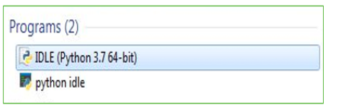
Step 3: Click on IDLE (Python 3.7 64-bit) and launch the program
Step 4: To go ahead with working in IDLE you must first save the file. Click on File > Click on Save

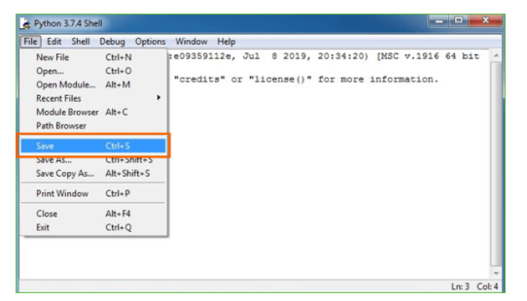
Step 5: Name the file and save as type should be Python files. Click on SAVE. Here I have named the files as Hey World.
Step 6: Now for e.g. enter print

6.SYSTEM TEST
The purpose of testing is to discover errors. Testing is the process of trying to discover every conceivable fault or weakness in a work product. It provides a way to check the functionality of components, sub assemblies, assemblies and/or a finished product It is the process of exercising software with the intent of ensuring that the Software system meets its requirements and user expectations and does not fail in an unacceptable manner. There are various types of test. Each test type addresses a specific testing requirement.

TYPES OF TESTS

Unit testing
Unit testing involves the design of test cases that validate that the internal program logic is functioning properly, and that program inputs produce valid outputs. All decision branches and internal code flow should be validated. It is the testing of individual software units of the application .it is done after the completion of an individual unit before integration. This is a structural testing, that relies on knowledge of its construction and is invasive. Unit tests perform basic tests at component level and test a specific business process, application, and/or system configuration. Unit tests ensure that each unique path of a business process performs accurately to the documented specifications and contains clearly defined inputs and expected results.

Integration testing
Integration tests are designed to test integrated software components to determine if they actually run as one program. Testing is event driven and is more concerned with the basic outcome of screens or fields. Integration tests demonstrate that although the components were individually satisfaction, as shown by successfully unit testing, the combination of components is correct and consistent. Integration testing is specifically aimed at exposing the problems that arise from the combination of components.

Functional test

Functional tests provide systematic demonstrations that functions tested are available as specified by the business and technical requirements, system documentation, and user manuals.
Functional testing is centered on the following items:
Valid Input : identified classes of valid input must be accepted.
Invalid Input : identified classes of invalid input must be rejected.
Functions : identified functions must be exercised.
Output : identified classes of application outputs must be exercised.
Systems/Procedures : interfacing systems or procedures must be invoked.
Organization and preparation of functional tests is focused on requirements, key functions, or special test cases. In addition, systematic coverage pertaining to identify Business process flows; data fields, predefined processes, and successive processes must be considered for testing. Before functional testing is complete, additional tests are identified and the effective value of current tests is determined.

System Test
System testing ensures that the entire integrated software system meets requirements. It tests a configuration to ensure known and predictable results. An example of system testing is the configuration oriented system integration test. System testing is based on process descriptions and flows, emphasizing pre-driven process links and integration points.

White Box Testing
White Box Testing is a testing in which in which the software tester has knowledge of the inner workings, structure and language of the software, or at least its purpose. It is purpose. It is used to test areas that cannot be reached from a black box level.

Black Box Testing

Black Box Testing is testing the software without any knowledge of the inner workings, structure or language of the module being tested. Black box tests, as most other kinds of tests, must be written from a definitive source document, such as specification or requirements document, such as specification or requirements document. It is a testing in which the software under test is treated, as a black box .you cannot “see” into it. The test provides inputs and responds to outputs without considering how the software works.
Unit Testing
Unit testing is usually conducted as part of a combined code and unit test phase of the software lifecycle, although it is not uncommon for coding and unit testing to be conducted as two distinct phases.
Test strategy and approach
Field testing will be performed manually and functional tests will be written in detail.
Test objectives
- All field entries must work properly.
- Pages must be activated from the identified link.
- The entry screen, messages and responses must not be delayed.

Features to be tested
- Verify that the entries are of the correct format
- No duplicate entries should be allowed
- All links should take the user to the correct page.

Integration Testing
Software integration testing is the incremental integration testing of two or more integrated software components on a single platform to produce failures caused by interface defects.
The task of the integration test is to check that components or software applications, e.g. components in a software system or – one step up – software applications at the company level – interact without error.
Test Results: All the test cases mentioned above passed successfully. No defects encountered.

Acceptance Testing
User Acceptance Testing is a critical phase of any project and requires significant participation by the end user. It also ensures that the system meets the functional requirements.
Test Results: All the test cases mentioned above passed successfully. No defects encountered.

- SCREENSHOTS
Double click on ‘run.bat’ file to get below screen
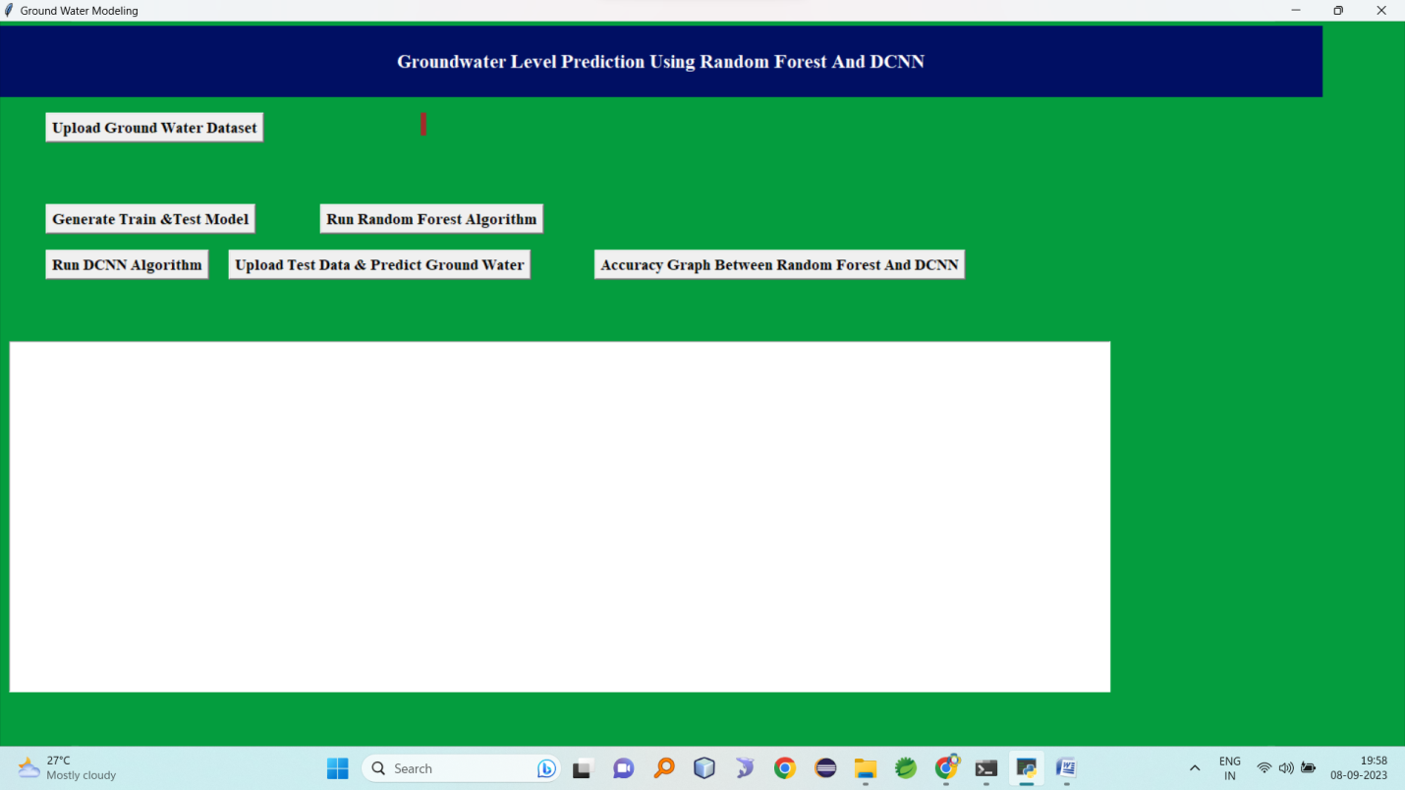
In above screen click on ‘Upload Ground Water Dataset’ button and upload dataset file
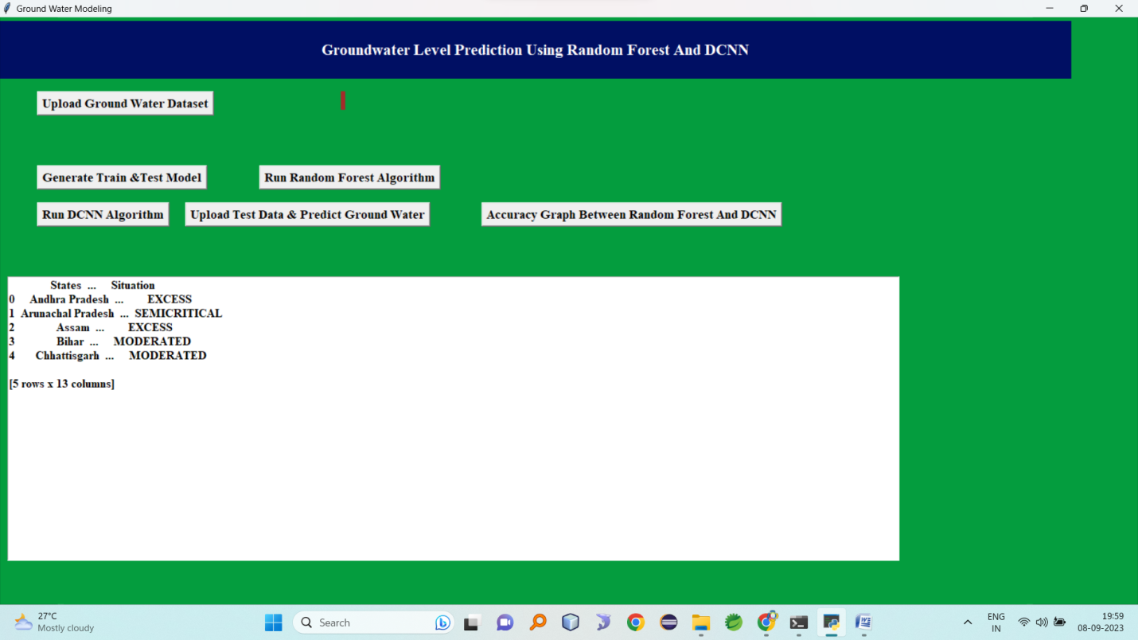

Now click on ‘Generate Train & Test Model’ button to split dataset into train and test model. All classifier will take 80% dataset for training and 20% dataset for testing.
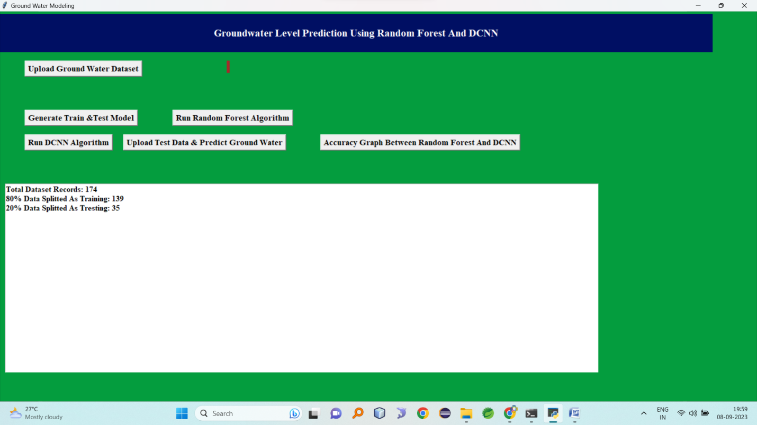
In above screen we can see total dataset size is 174 and application using 139 records for training and 35 for testing. Now dataset model generated and now click on ‘Run Random Forest Algorithm’ to generate random forest model and to compare random forest accuracy with propose DCNN algorithm
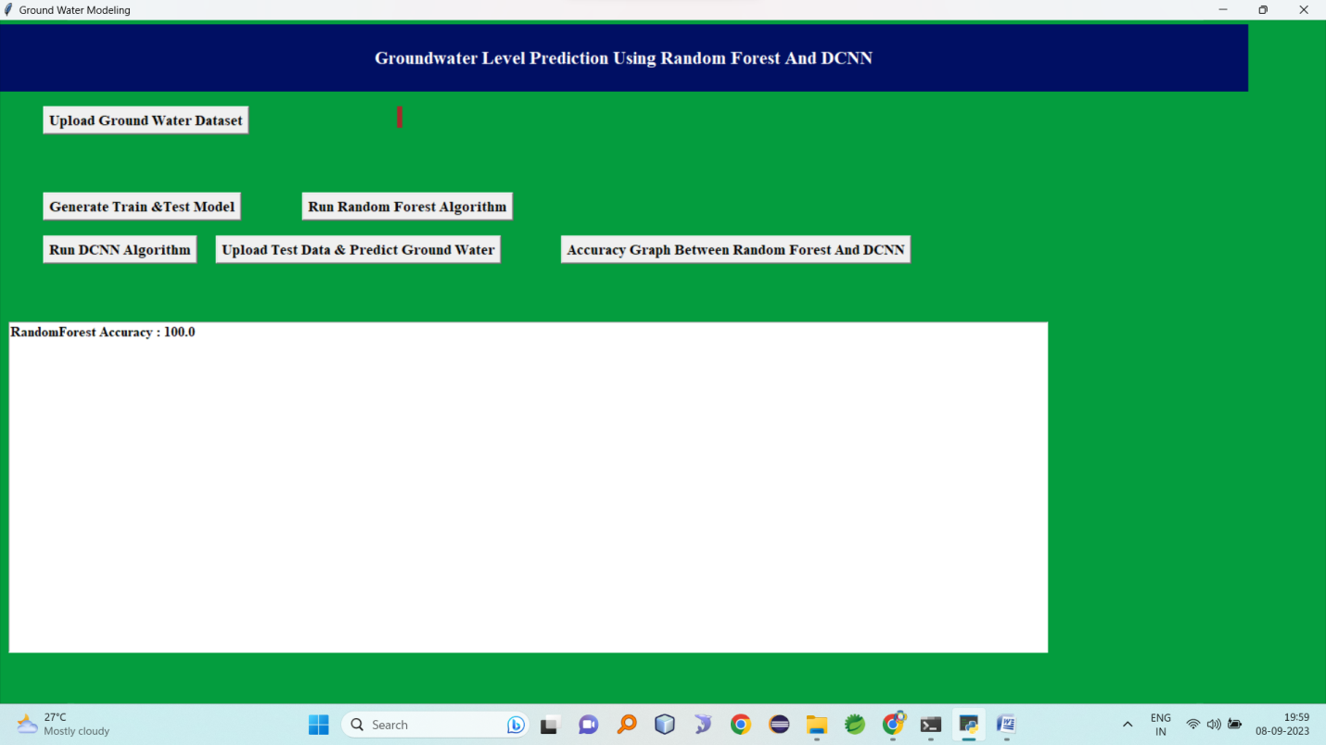
In above screen random forest got 100% accuracy to predict ground water level on all test data. Now click on ‘Run DCNN Algorithm’ button to generate DCNN model and to get its prediction accuracy
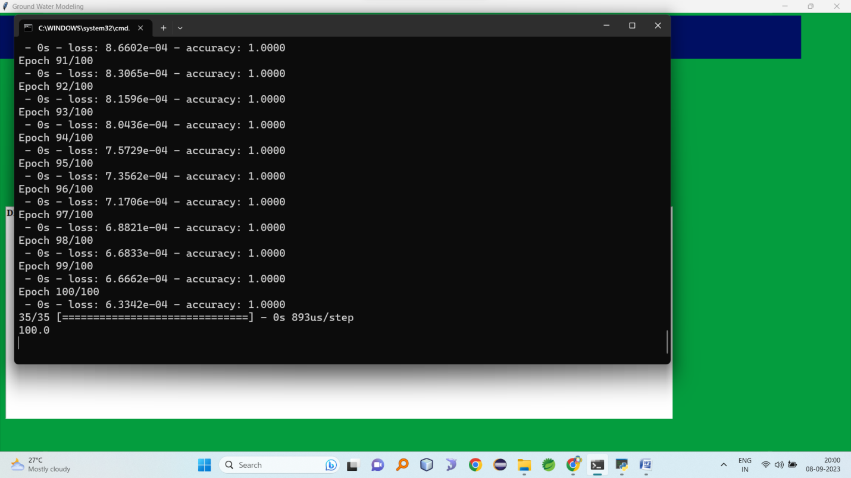
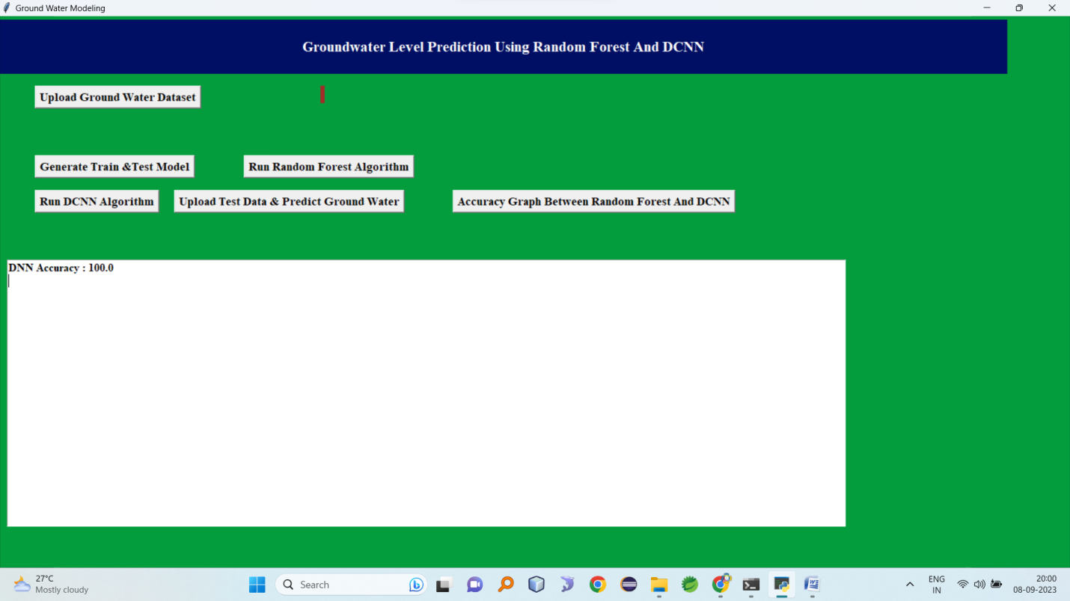
In above screen we can see DCNN got 100% accuracy. Now model is ready and now we can upload test data and predict ground level
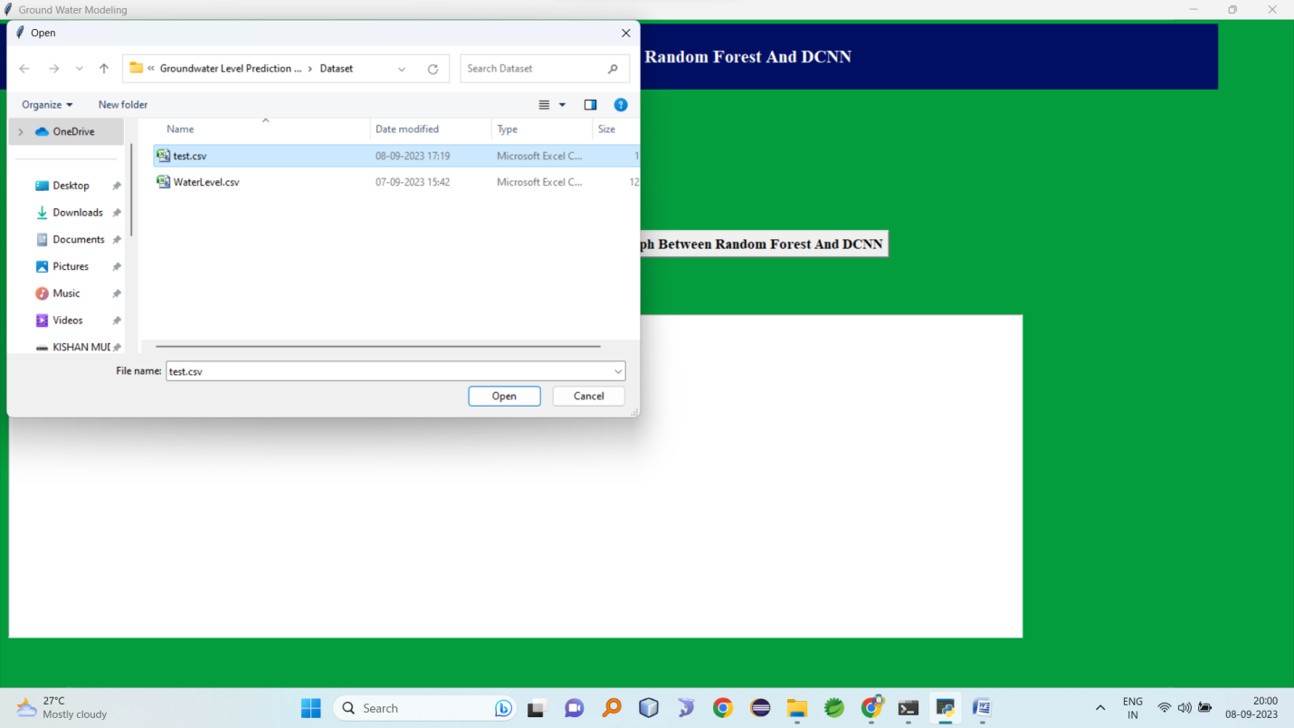
In above screen I am uploading ‘test.csv file and now click on ‘Open’ button to predict Ground level for test data
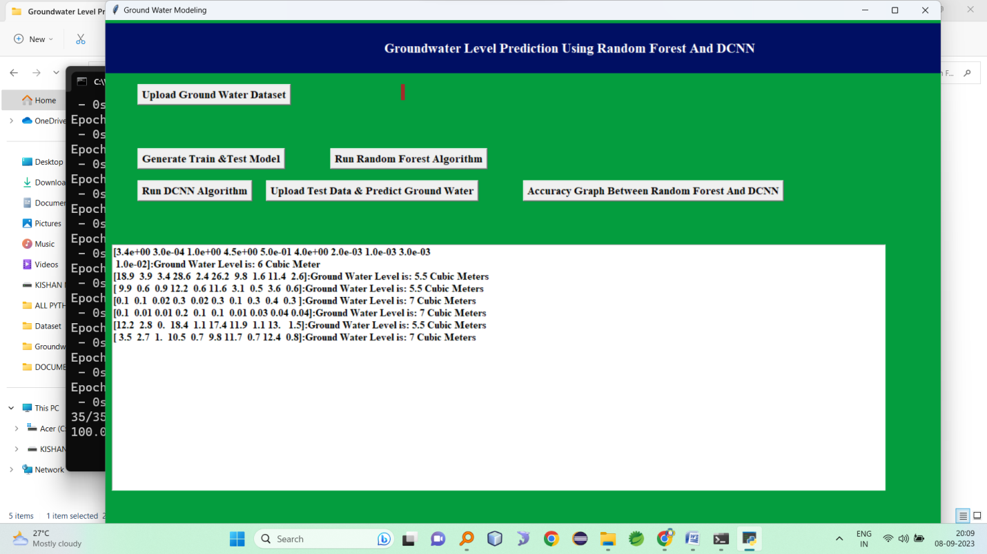
In above screen we got water level prediction for all test records. Water level predicted as 5 and 7 cubic meter. Now click on ‘Accuracy Graph Between Random Forest & DCNN’ button to get comparison between Random Forest and DCNN
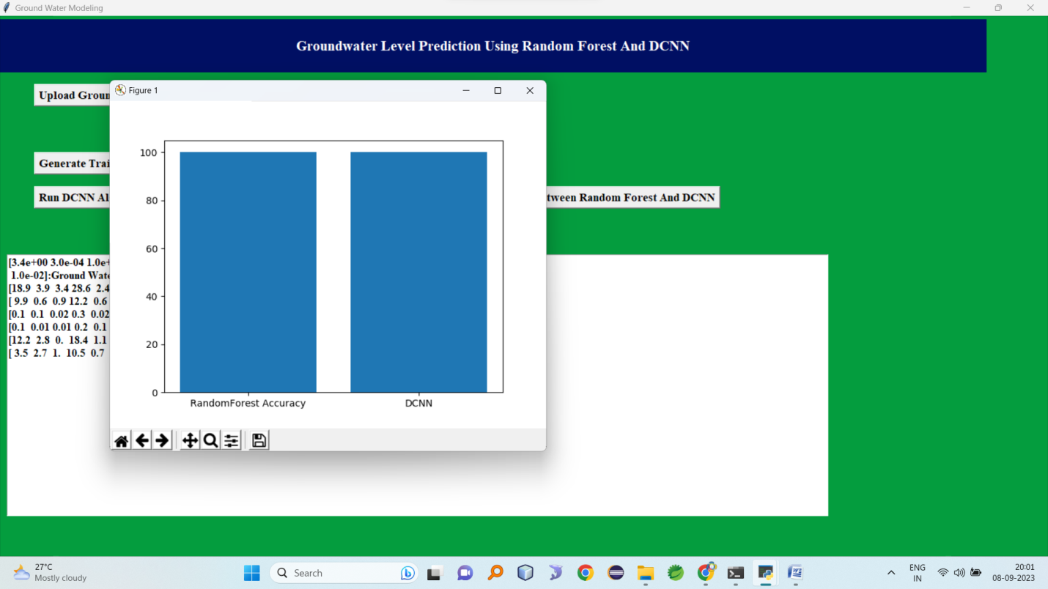
In above graph x-axis represents algorithm name and y-axis represents accuracy of those algorithms.

8.CONCLUSION
Mathematical models are tools, which are frequently used in studying groundwater systems. In general, mathematical models are used to simulate (or to predict) the groundwater flow and in some cases the solute and/or heat transport. Predictive simulations must be viewed as estimates, dependent upon the quality and uncertainty of the input data. Models may be used as predictive tools, however field monitoring must be incorporated to verify model predictions. The best method of eliminating or reducing modelling errors is to apply good hydrogeological judgement and to question the model simulation results.

9. REFERENCES
1.Anderson, P.F., Mercer, J.W. and White, H.O. (1988) Numerical modelling of salt water intrusion at Hallandale, Florida Ground Water 26, 619–630.
2.Bachmat, Y., van der Heijde, P., Bredehoeft, J., Andrews, B., Holz, D. and Sebastian, S. (1986) Groundwater management: the use of models. American Geophysical Union, Water Resources Monograph 5, 180pp.
3.Bliss, J.C. and Rushton, K.R. (1984) The reliability of packer tests for estimating the hydraulic conductivity of aquifers Quart. Jnl. Eng. Geol. 17, 81–91.
4.Bouwer, H. (1969) Theory of seepage from open channels in Advances in Hydroscience 5, Academic Press, New York, 121–172.Google Scholar
5.Brassington, F.C. and Walthall, S. (1985) Field techniques using borehole packers in hydrogeological investigations Quart. Jnl. Eng. Geol. 18, 183–193. Connorton, B.J. (1985) Does the regional groundwater-flow equation model vertical flow? Jnl. of Hydrology 79, 279–299.
6.Connorton, B.J. and Reed, R.N. (1978) A numerical model for the prediction of long term well yield in an unconfined chalk aquifer Quart. Jnl. Eng. Geol. 11, 127.
7.Feddes, R.A., Kabat, P., van Bakel, P.J.T, Bronswijk, J.J.B. and Halbertsma, J. (1988) Modelling of soil water dynamics in the unsaturated zone — state of the art Jnl of Hydrology 100, 69–111. Franke, O.L., Reilley, T.E. and Bennett, G.D. (1984) Definition of boundary and initial conditions in the analysis of saturated ground-water flow systems — An introduction, U.S. Geological Survey Open-File Report 84-458, 26pp.
8.Kinzelbach, W. (1986) Groundwater Modelling: An Introduction with Programs in BASIC, Developments in Water Science 25, Elsevier, 333pp.
9.Huyakorn, P.S. and Pinder, G.F. (1983) Computational Methods in Subsurface Flow, Academic Press, 473pp.
10.Gomez-Hernandez, J.J. and Gorelick, S.M. (1989) Effective groundwater model parameter values: influence of spatial variability of hydraulic conductivity, leakance and recharge Water Resources Research 25, 405–419.
11.Gonzalez, Maria del Mar and Rushton, K.R. (1981) Deviations from classical behaviour in pumping test analysis Ground Water 19, 510–516.
12.Rushton, K.R. (1985) Interference due to neighbouring wells during pumping tests Gound Water 23, 361–366.
13.Rushton, K.R., Kawecki, M.W. and Brassington, F.C. (1988) Groundwater model of conditions in Liverpool Sandstone Aquifer.
14.Jnl. Instn. Wat. and Envir. Man. 2, 67–84.
15.Rushton, K.R. and Rao, S.V. (1988) Groundwater flow through a Miliolite Limestone Aquifer Hydrological Sciences Journal 33, 449–464.
16.Rushton, K.R. and Rathod, K.S. (1985) Horizontal and vertical components of flow deduced from groundwater heads Jnl. of Hydrology 79, 261–278.
17.Rushton, K.R. and Redshaw, S.C. (1979) Seepage and Groundwater Flow, Wiley, Chichester, 332pp.
18.Rushton, K.R., Smith, E.J. and Tomlinson, L.M. (1982) An improved understanding of flow in a limestone aquifer using field evidence and mathematical models Jnl. Inst. Wat. Eng. and Sci, London 36, 369–387.
19.Rushton, K.R. and Srivastava, N.K. (1988) Response to pumping of a weathered-fractured granite aquifer Jnl. of Hydrology 80, 299–309.
20.Rushton, K.R. and Ward, C. (1979) The estimation of groundwater recharge Jnl. of Hydrology 41, 345–361.
21.Rushton, K.R. and Weller, J. (1985) Response to pumping of a weathered-fractured granite aquifer Jnl. of Hydrology 80, 299–309.
22.Simmers, I.(Ed) (1988) Estimation of Natural Groundwater Recharge, NATO ASI Series C, Reidel Pub. Co. Holland, 510pp.
23.Theis, C.V. (1935) The relation between the lowering of the piezometric surface and the rate and duration of discharge of a well using ground-water storage Am. Geophys. Union Trans. 16, 519–524.
24.Wang, H.F. and Anderson, M.P. (1982) Introduction to Groundwater Modeling, W.H. Freeman & Co., San Francisco, 237pp.
25.Ward, D.S., Buss, D.R., Mercer, J.W. and Hughes, S.S. (1987) Evaluation of a groundwater corrective action of the Chem-Dyne hazardous waste site using a telescopic mesh refinement modeling approach Water Resources Research 23, 603–617.
26.Wachyan, E and Rushton, K.R. (1987) Water losses from irrigation canals Jnl. of Hydrology 92, 275–288.
27.Youngs, E.G. (1988) Soil physics and hydrology Jnl. of Hydrology 100, 411–431

